

Motorola A1200

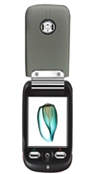
Description

Motorola A1200 is a QVGA color touch display phone with a 2 megapixel camera. This linux operating GSM phone has a transparent front cover. The internal memory is extended through microSD memory cards, which can store music in various formats.

STORE PRICE: Rs 9,904 /-
ONLINE PRICE: Rs 9,855 /-

Brand : Motorola
Model Name : A1200
Released Year : 2006
Phone Memory : 8 MB user memory
External Memory : microSD(TransFlash)
Colors : Black, Red, Silver
Form : Flip
Dimensions : 95.7 x 51.7 x 21.5 mm
Weight : 122 g

